Amrita Vishwa Vidyapeetham
Amrita School of Computing, Amritapuri
BTech Computer Science and Engineering (AI)
22AIE311 – Software Engineering (Project based)
LAB SHEET 2 — ELABORATION PHASE
AI-Powered Personal Resource Optimization & Subscription Intelligence System (PROSIT)

PART A – USE CASE MODELING [CO04]
Task 1: Identify Actors
Sl. No | Actor Name | Description
1 | Registered User | Primary actor. An authenticated user who manages subscriptions, monitors device usage, views analytics, sets goals, and receives notifications.
2 | Guest / New User | Unauthenticated visitor who can register for a new account or view the landing page.
3 | Admin | System administrator who manages user accounts, monitors system health, and configures platform-level settings.
4 | Android App | Companion mobile application running on the user's Android device. Tracks foreground app usage and sends data to the backend API.
5 | Windows Agent | Desktop monitoring agent running on the user's Windows machine. Tracks active application/process usage and pushes data to the backend.
6 | Notification Service | External service (Firebase Cloud Messaging / SendGrid) that delivers push notifications and email alerts to users.
Task 2: Identify Use Cases
Use Case ID | Use Case Name | Actor(s) | Description
UC01 | Register Account | Guest User | New user registers with name, email, and password. System validates and creates account.
UC02 | Login | Registered User, Guest User | User authenticates via email/password; system issues JWT token upon success.
UC03 | Logout | Registered User | User invalidates session/token and is redirected to landing page.
UC04 | Add Subscription | Registered User | User adds a new subscription with name, cost, billing cycle, and category.
UC05 | Edit Subscription | Registered User | User modifies details of an existing subscription.
UC06 | Delete Subscription | Registered User | User permanently removes a subscription from the system.
UC07 | Pause Subscription | Registered User | User temporarily pauses a subscription; cost is excluded from active totals.
UC08 | View Dashboard | Registered User | User views aggregated spending, usage statistics, and AI-generated insights on main dashboard.
UC09 | View Analytics | Registered User | User explores detailed metrics: cost-per-hour, ROI, utilization rate, opportunity cost.
UC10 | Set Goals | Registered User | User defines personal time or money goals (e.g., reduce streaming spend to $20/month).
UC11 | Track Goal Progress | Registered User | User monitors how current behavior compares against defined goals.
UC12 | Generate Report | Registered User | System generates a weekly/monthly summary report of subscription spend and usage.
UC13 | Receive Notification | Registered User, Notification Svc | User receives email/push alerts for renewals, low usage warnings, or recommendations.
UC14 | Send Android Usage Data | Android App | Android companion app collects foreground app session data and pushes it to backend API.
UC15 | Send Windows Usage Data | Windows Agent | Windows agent collects active process/window usage and posts it to backend API.
UC16 | Manage Users | Admin | Admin views, deactivates, or removes user accounts from the admin panel.
UC17 | Configure Profile | Registered User | User updates display name, password, notification preferences, and connected devices.
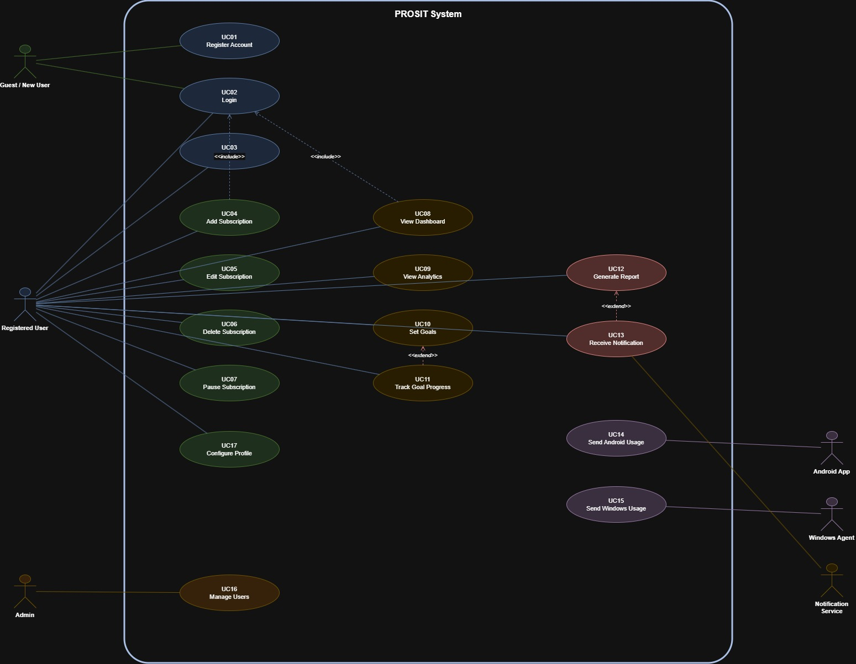
Task 3: Use Case Diagram

The Use Case Diagram captures all actors and their interactions with the PROSIT system. Key relationships include:
• «include»: Login is included by Add/Edit/Delete Subscription, View Dashboard, View Analytics, Set Goals.
• «extend»: Receive Notification extends Generate Report (optional alert on completion).
• «extend»: Track Goal Progress extends Set Goals.
• Android App and Windows Agent interact only with UC14 and UC15 respectively.
PART B – ACTIVITY MODELING [CO04]
Task 4: Key Activities in System Workflow
# | Activity | Triggered By
1 | User Registration & Email Verification | Guest User
2 | User Login / Authentication (JWT issue) | Registered User
3 | Add / Edit / Delete / Pause Subscription | Registered User
4 | Collect Android App Usage Data | Android App (background service)
5 | Collect Windows Process Usage Data | Windows Agent (background process)
6 | Aggregate & Store Usage Records | Backend API
7 | Compute Cost-per-Hour & ROI Metrics | Analytics Engine
8 | Generate AI-Powered Recommendations | Analytics Engine
9 | Render Dashboard with Charts | Frontend (React)
10 | Set / Update Goals | Registered User
11 | Evaluate Goal Progress | Analytics Engine
12 | Generate Weekly / Monthly Report | Scheduler (cron job)
13 | Send Notification (email / push) | Notification Service
14 | Admin: Manage User Accounts | Admin
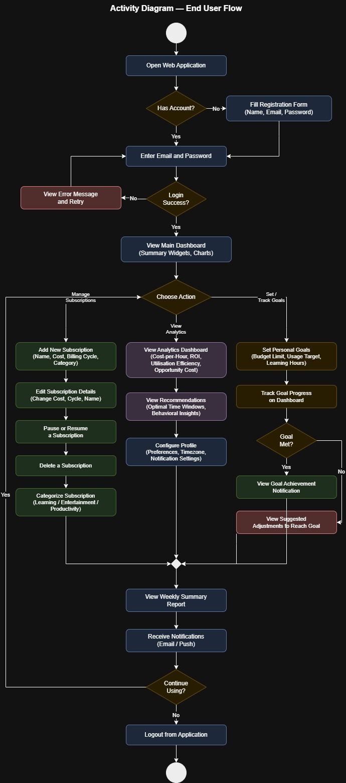
Task 5: Activity Diagram

The Activity Diagram models the primary user workflow: from login through subscription management to analytics viewing and goal tracking. Decision points include authentication success/failure, device monitoring consent, and goal achievement status.

PART C – DATA FLOW MODELING (DFD) [CO04]
Task 6: System Inputs and Outputs
Inputs | Outputs
User credentials (email, password) | JWT access token / authentication response
Subscription details (name, cost, cycle, category) | Subscription list with analytics metadata
Android app usage data (app name, duration, timestamp) | Analytics report (cost-per-hour, ROI, utilization)
Windows process usage data (process name, window title, duration) | AI recommendations & optimization suggestions
Goal definitions (target, metric, deadline) | Goal progress report
User profile updates | Weekly / monthly summary notifications
Report generation request | PDF / JSON usage & cost report
Admin actions (deactivate/remove user) | Updated user status confirmation
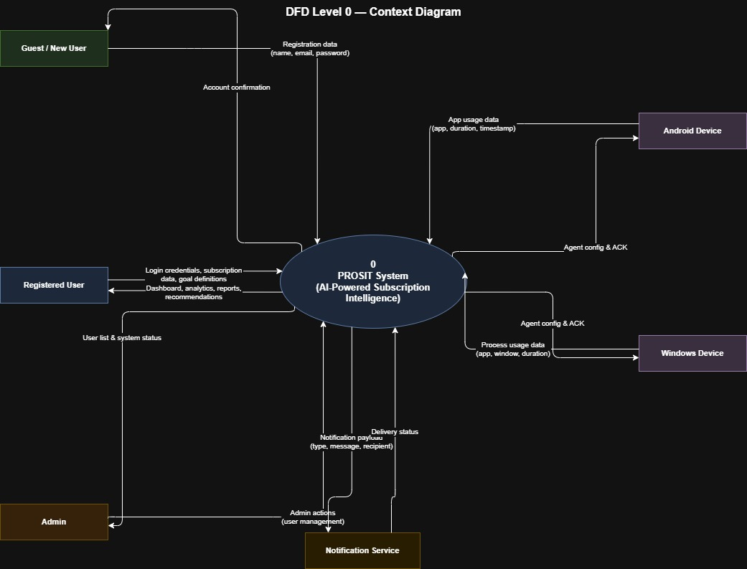
Task 7: DFD Level 0 — Context Diagram

The context diagram represents the entire PROSIT system as a single process. External entities: Registered User, Guest User, Admin, Android Device, Windows Device, and Notification Service. All data flows to/from the system are shown at this level.
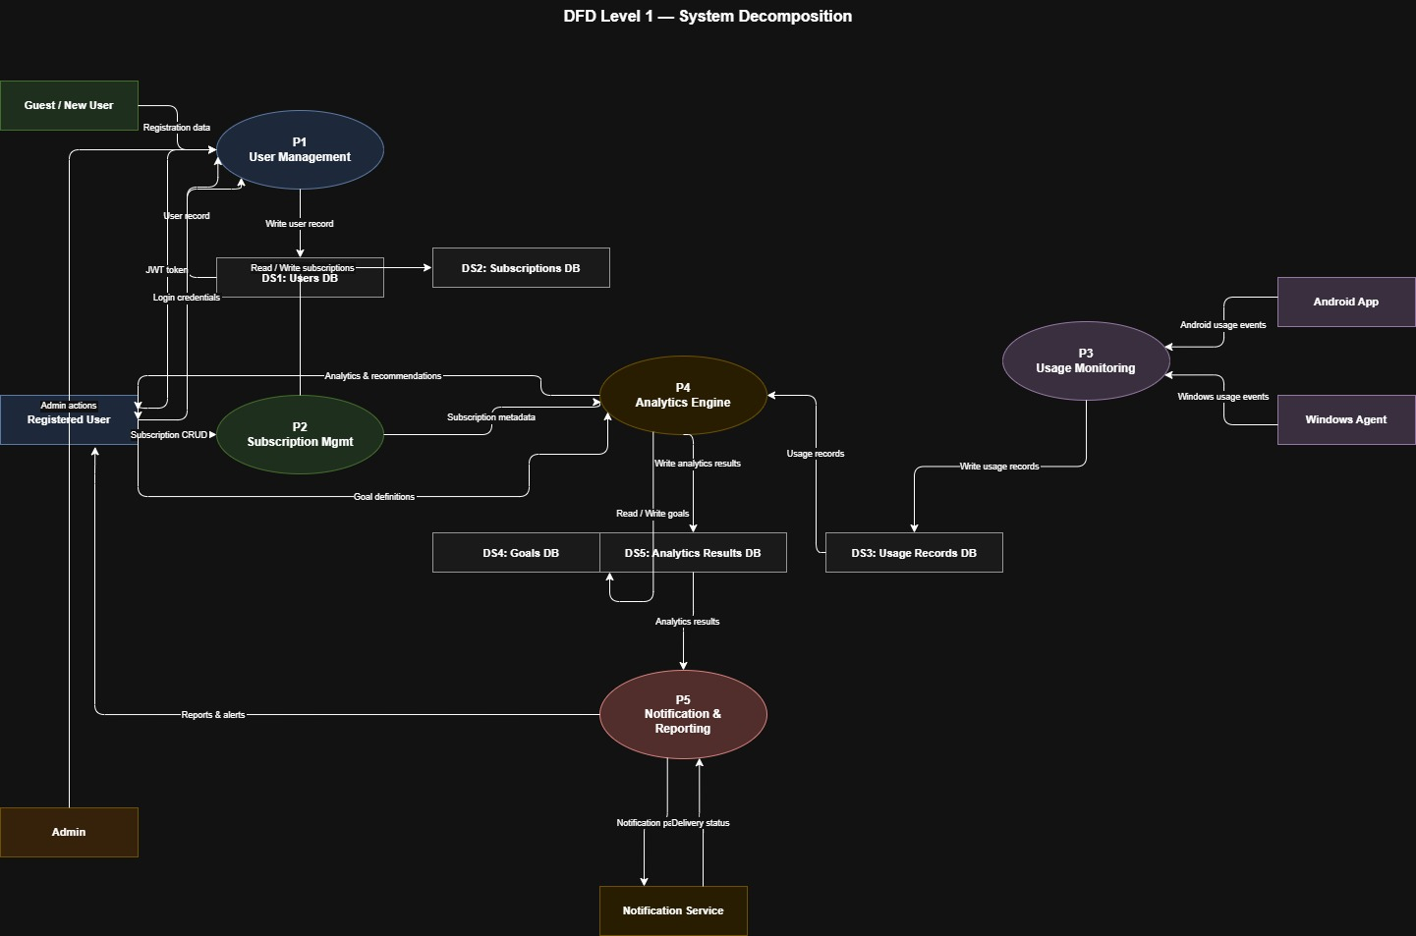
Task 8: DFD Level 1

Level 1 decomposes the system into five major sub-processes:
P1 – User Management | P2 – Subscription Management | P3 – Usage Monitoring
P4 – Analytics Engine | P5 – Notification & Reporting
Data stores: DS1 Users DB, DS2 Subscriptions DB, DS3 Usage Records DB, DS4 Goals DB.

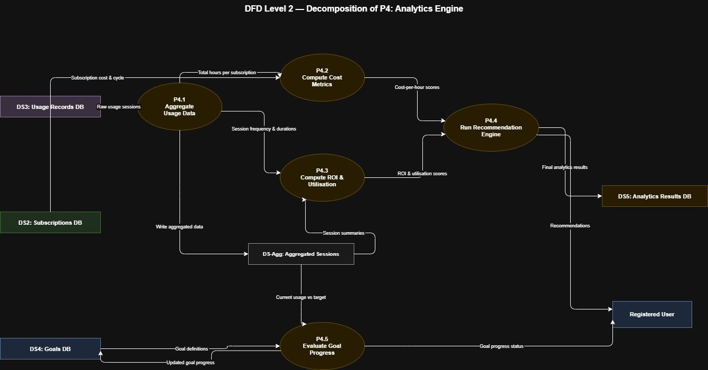
Task 9: DFD Level 2

Level 2 further decomposes P4 – Analytics Engine into:
P4.1 – Aggregate Usage Data P4.2 – Compute Cost Metrics P4.3 – Generate ROI & Utilization
P4.4 – Run Recommendation Engine P4.5 – Evaluate Goals

PART D – CLASS DIAGRAM MODELING [CO04]
Task 10: Identify Classes
Sl. No | Class Name | Type | Description
1 | User | Entity | Stores registered user credentials, profile info, and preferences.
2 | Subscription | Entity | Represents a subscription service with cost, billing cycle, and category.
3 | UsageRecord | Entity | Captures app/process usage session: device type, app name, duration, timestamp.
4 | Goal | Entity | Stores user-defined time or money goals with target metrics and deadlines.
5 | AnalyticsResult | Entity | Stores computed metrics: cost-per-hour, ROI, utilization rate for a subscription.
6 | Notification | Entity | Stores notification payload, type, status, and recipient for audit.
7 | Report | Entity | Represents a generated weekly/monthly usage and spend report.
8 | LoginForm | Boundary | Frontend UI component for user login (email + password form).
9 | DashboardView | Boundary | Frontend component rendering the main analytics dashboard with charts.
10 | SubscriptionFormView | Boundary | Frontend form UI for adding or editing a subscription.
11 | GoalFormView | Boundary | Frontend UI for creating or updating a personal goal.
12 | DeviceAgentInterface | Boundary | API interface through which Android/Windows agents push usage data.
13 | AuthController | Control | Handles registration, login, JWT issuance, and session validation.
14 | SubscriptionController | Control | Orchestrates CRUD operations on subscriptions and category management.
15 | UsageController | Control | Receives, validates, and stores device usage data from agents.
16 | AnalyticsController | Control | Triggers analytics computation, retrieves results, and surfaces recommendations.
17 | GoalController | Control | Manages goal creation, updates, and progress evaluation logic.
18 | NotificationController | Control | Triggers notification dispatch via external service; manages delivery status.
19 | ReportController | Control | Schedules and generates periodic usage/cost summary reports.
Task 11: Attributes and Methods
Class Name | Attributes | Methods
User | userId: UUID name: String email: String passwordHash: String createdAt: DateTime notifyPrefs: JSON | register() login() logout() updateProfile() deleteAccount()
Subscription | subId: UUID userId: UUID name: String cost: Float billingCycle: Enum category: Enum status: Enum startDate: Date nextRenewal: Date | create() update() delete() pause() resume() getAll()
UsageRecord | recordId: UUID userId: UUID deviceType: Enum appName: String duration: Int (seconds) timestamp: DateTime | save() getByUser() getBySubscription() getByDateRange()
Goal | goalId: UUID userId: UUID title: String metric: Enum targetValue: Float currentValue: Float deadline: Date status: Enum | create() update() evaluateProgress() markAchieved()
AnalyticsResult | resultId: UUID subId: UUID userId: UUID costPerHour: Float roiScore: Float utilizationRate: Float period: String computedAt: DateTime | compute() getBySubscription() getSummary() getRecommendations()
Notification | notifId: UUID userId: UUID type: Enum message: String status: Enum sentAt: DateTime | send() markRead() getUnread() getAll()
Report | reportId: UUID userId: UUID period: String type: Enum filePath: String generatedAt: DateTime | generate() download() getAll() delete()
AuthController | (no state — controller) | register(req, res) login(req, res) logout(req, res) validateToken(token) refreshToken(req, res)
AnalyticsController | (no state — controller) | computeAnalytics(userId) getDashboardData(userId) getRecommendations(userId) evaluateGoals(userId)
Task 12: Identify Relationships
Class 1 | Relationship | Class 2 | Description
User | Association (1..*) | Subscription | A user owns one or more subscriptions.
User | Association (1..*) | UsageRecord | A user has many usage records across devices.
User | Association (1..*) | Goal | A user sets one or more goals.
User | Association (1..*) | Notification | A user receives multiple notifications.
User | Association (1..*) | Report | A user can generate multiple reports.
Subscription | Association (1..*) | UsageRecord | A subscription is associated with multiple usage sessions.
Subscription | Composition (1..1) | AnalyticsResult | Each subscription has exactly one computed analytics result (recomputed periodically).
AnalyticsResult | Aggregation (1..*) | UsageRecord | Analytics result aggregates multiple usage records.
Goal | Association (0..*) | AnalyticsResult | Goals are evaluated against computed analytics results.
AuthController | Dependency | User | AuthController reads and creates User entities.
SubscriptionController | Dependency | Subscription | SubscriptionController manages Subscription entities.
AnalyticsController | Dependency | AnalyticsResult | AnalyticsController triggers and reads AnalyticsResult.
GoalController | Dependency | Goal | GoalController manages Goal entities and evaluates progress.
NotificationController | Dependency | Notification | NotificationController creates and dispatches Notification.
ReportController | Dependency | Report | ReportController generates and stores Report entities.
LoginForm | Dependency | AuthController | LoginForm invokes AuthController for authentication.
DashboardView | Dependency | AnalyticsController | DashboardView fetches analytics data via AnalyticsController.
SubscriptionFormView | Dependency | SubscriptionController | SubscriptionFormView calls SubscriptionController for CRUD.
DeviceAgentInterface | Dependency | UsageController | Device agents push data through UsageController.

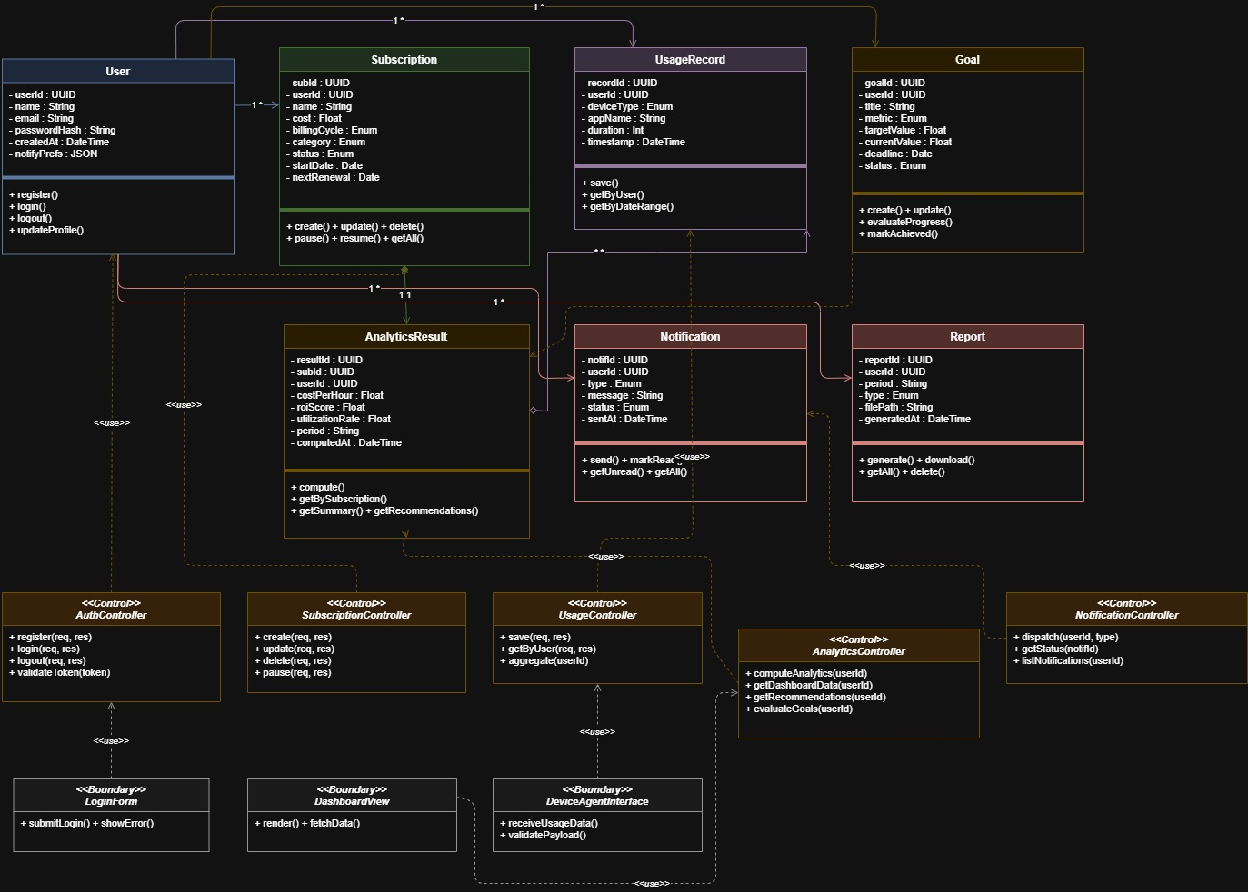
Task 13: Class Diagram

The class diagram includes all 19 classes across Entity, Boundary, and Control layers, showing full attributes, methods, multiplicities, and relationship types (association, composition, aggregation, dependency).
Task 14: Justification of Design
The class model follows a three-layer MVC-aligned architecture. Entity classes (User, Subscription, UsageRecord, Goal, AnalyticsResult, Notification, Report) directly map to database tables, ensuring a clean ORM boundary. Boundary classes represent the frontend UI components and external API interfaces, deliberately separating presentation concerns from business logic. Control classes act as service/controller layers handling orchestration — each controller is scoped to a single domain (auth, subscriptions, analytics, etc.) to enforce the Single Responsibility Principle. Relationships were identified from data ownership (User owns Subscription via foreign key) and computation dependencies (AnalyticsResult aggregates UsageRecords). Composition was used for AnalyticsResult-Subscription because the result has no meaning outside its parent subscription. This design supports scalability, testability, and clean API boundary definition.

